

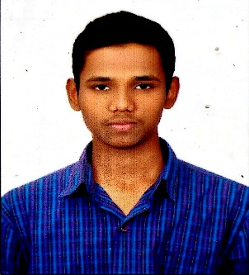MOHAMMAD ZIA UL RAHMAN

# Education and certificates

Bachelor of Technology

Computer Science and Engineering: 2017 - 2021

**Skills**

Java 8

Spring MVC

## Base Location:

Mumbai

Spring Boot

# Strengths

## Email ID: Mobile No:

## Grade: A4

[ZIA-UL-RAHMAN.MOHAMMAD@capgemini.com](mailto:ZIA-UL-RAHMAN.MOHAMMAD@capgemini.com)

8341934186

# Achievement

**Backend** Spring Boot Spring Core Rest API Node Js

### Bigdata Technologies

Scala Kafka Akka

* Software Engineer who is Strong in design and integration with intuitive problem-solving skills. Passionate about implementing and launching new projects.
* Ready to learn new technologies and implement them to further improve of my knowledge.
* Eager to work in a team of dedicated people and serve a key role in the enhancement and development of the

project.

* Has working knowledge on Angular and Java Development using Spring framework on an intermediate level.

https://github.com/ZiaRahmann/OnePageResume.git

**E-Auction System:**

Complete end to end case study of e- auction system using Spring Boot REST API and Swagger. Securely implemented authentication with JWTs. Created UI using HTML, CSS, Bootstrap and Angular.

### Shopping Cart Management System:

Created an Online Shopping Cart System Microservice Application using spring boot as backend along with swagger for testing. Angular as frontend, used HTML5, CSS, ES6 and bootstrap for designing responsive web pages

**Database** PostgreSQL SQL database

### Web Technologies

HTML5 CSS3

JavaScript

TypeScript

Bootstrap

Angular

**AddOns** GitHub

Gradle

Swagger

Eclipse

### Additional Details

Leadership

Proficient Communication

Team management